







BIT 2304 – PROJECT DEFINITION
MOD 6 - Optimization in Networks

Learning Objectives
- Optimization in Networks
- Shortest paths such as;
- Floyd’s algorithm,
- CPM (Critical Path Method) and
- PERT (Project and Evaluation Techniques)
- Maximal flow
- Dynamic Programming
- Transshipment model
- Service tours and vehicle scheduling
- Savings and other heuristic methods
- Urban transport planning
- Traffic flows
- Inventory models.
- Gantt Chart

Optimization in Networks
  - Network optimization initiatives provide the ability to determine the costs and benefits of adapting a company’s overall network in response to such changes during research process.

Floyd’s algorithm
  - In computer science, the Floyd–Warshall algorithm is an algorithm for finding shortest paths in a directed weighted graph with positive or negative edge weights.
  - A single execution of the algorithm will find the lengths of shortest paths between all pairs of vertices.

  - Floyd-Warshall Algorithm is an algorithm for finding the shortest path between all the pairs of vertices in a weighted graph.
  - This algorithm works for both the directed and undirected weighted graphs.
  - But, it does not work for the graphs with negative cycles (where the sum of the edges in a cycle is negative).
  - A weighted graph is a graph in which each edge has a numerical value associated with it.

How Floyd-Warshall Algorithm Works? Let the given graph be:

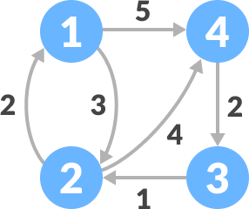
Initial graph

  - Follow the steps below to find the shortest path between all the pairs of vertices.
  - Create a matrix A0 of dimension n*n where n is the number of vertices.
    - The row and the column are indexed as i and j respectively.
    - i and j are the vertices of the graph.
    - Each cell A[i][j] is filled with the distance from the ith vertex to the jth vertex.
    - If there is no path from ith vertex to jth vertex, the cell is left as
infinity.

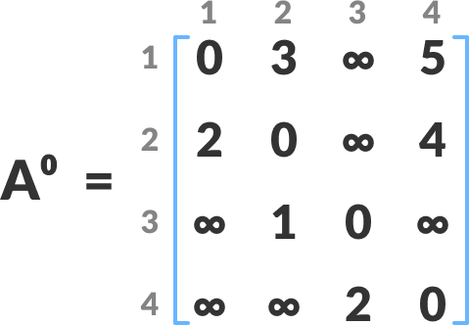

Fill each cell with the distance between ith and jth vertex

  - Now, create a matrix A1 using matrix A0.
    - The elements in the first column and the first row are left as they are.
    - The remaining cells are filled in the following way:
Let k be the intermediate vertex in the shortest path from source to destination.
    - In this step, k is the first vertex.
    - A[i][j] is filled with (A[i][k] + A[k][j]) if (A[i][j] > A[i][k] + A[k][j]).
    - That is, if the direct distance from the source to the destination is greater than the path through the vertex k,
    - then the cell is filled with A[i][k] + A[k][j].

    - In this step, k is vertex 1.
    - We calculate the distance from source vertex to destination vertex through

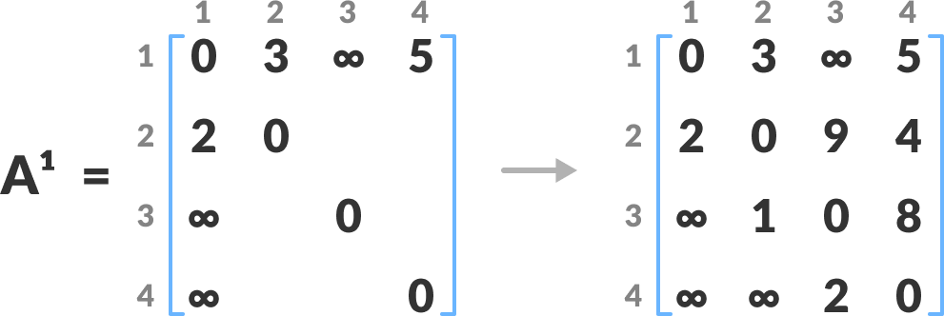

Calculate the distance from the source vertex to destination vertex through this vertex k

For example: For A1[2, 4], the direct distance from vertex 2 to 4 is 4 and the sum of the distance from vertex 2 to 4 through vertex (i.e. from vertex 2 to 1 and from vertex 1 to 4) is 7.
      - Since 4 < 7, A0[2, 4] is filled with 4.

      - Similarly, A2 is created using A1.
      - The elements in the second column and the second row are left as they are.

      - In this step, k is the second vertex (i.e. vertex 2).
      - The remaining steps are the same as in step 2.

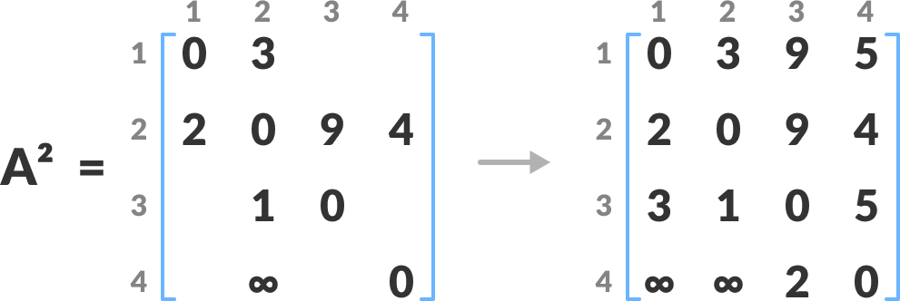

        - Calculate the distance from the source vertex to destination vertex
through this vertex 2

4. Similarly, A3 and A4 is also created.

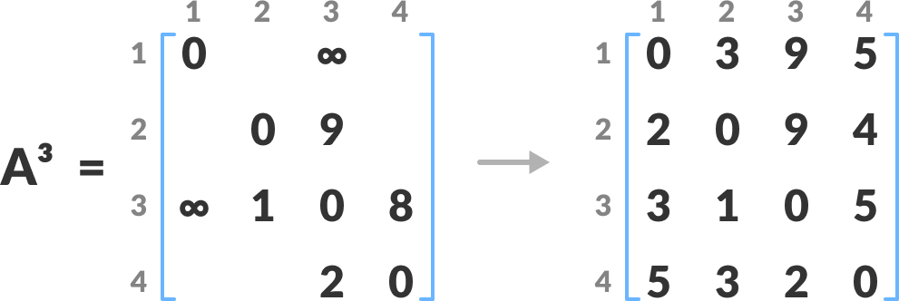

- Calculate the distance from the source vertex to destination vertex through this vertex 3

CPM (Critical Path Method)
    - Critical path method (CPM) is a technique where you identify tasks that are necessary for project completion and determine scheduling flexibilities.
    - A critical path in project management is the longest sequence of activities that must be finished on time in order for the entire project to be complete.
    - The critical path method, or critical path analysis, is an algorithm for scheduling a set of project activities.
    - It is commonly used in conjunction with the program evaluation and review technique.

When to apply CPM
      - Each of these projects has several characteristics that are essential for analysis by CPM:
- The project consists of a well-defined collection of jobs (or activities) which, when completed, mark the end of the project.
- The jobs may be started and stopped independently of each other, within a given sequence. (This requirement eliminates continuous- flow process activities, such as oil refining, where “jobs” or operations necessarily follow one after another with essentially no slack.)
- The jobs are ordered—that is, they must be performed in technological sequence. (For example, the foundation of a house must be constructed before the walls are erected.)

Two important applications of CPM features
- Du Pont, a pioneer in the application of CPM to construction and maintenance projects, was concerned with the amount of downtime for maintenance at its Louisville works, which produces an intermediate product in the neoprene process.
  - Analyzing the maintenance schedule by CPM, Du Pont engineers were able to cut downtime for maintenance from 125 to 93 hours.
  - CPM pointed to further refinements that were expected to reduce total time to 78 hours.
  - As a result, performance of the plant improved by about one million pounds in 1959, and the intermediate was no longer a bottleneck in the neoprene process.

    - The DuPont model is a classic tool for any investors toolbox and many even consider it an essential part of any analysis.
    - The DuPont Analysis equation breaks a company’s Return on Equity (ROE) down into three core elements;
- Profit Margin
- Asset Turnover, and
- Financial Leverage

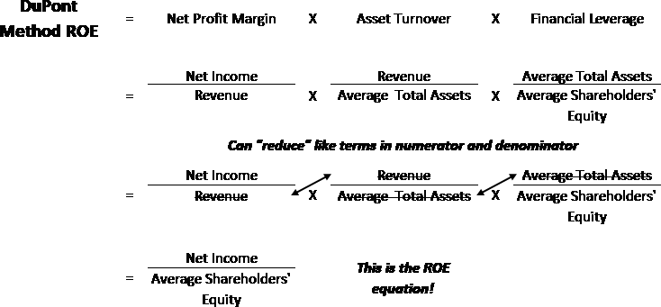

- PERT (i.e., Program Evaluation Review Technique), a technique closely related to the critical path method, is widely credited with helping to shorten by two years the time originally estimated for completion of the engineering and development program for the Navy’s Polaris missile.
    - By pinpointing the longest paths through the vast maze of jobs necessary for completion of the missile design, PERT enabled the program managers to concentrate their efforts on those activities that vitally affected total project time.

PERT Chart

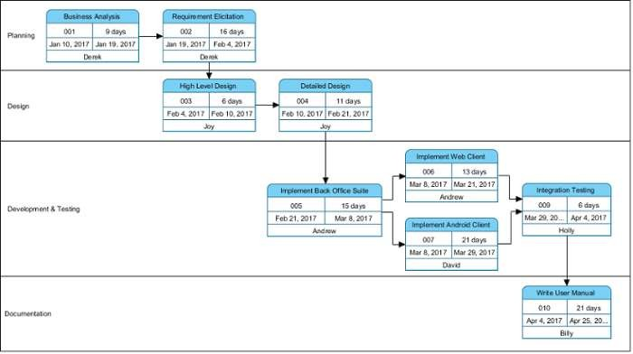
MOD 6 - Optimization in Networks 21

Maximal Flow

In optimization theory, maximum flow problems involve finding a feasible flow through a flow network that obtains the maximum possible flow rate.
    - The maximum flow problem can be seen as a special case of more complex network flow problems, such as the circulation problem.

Maximum flow is defined as the maximum amount of flow that the network would allow to flow from source to sink.
    - Multiple algorithms exist in solving the maximum flow problem.
    - Two major algorithms to solve these kind of problems are Ford- Fulkerson algorithm and Dinic's Algorithm.

    - In graph theory, a flow network is defined as a directed graph involving a source(S) and a sink(T) and several other nodes connected with edges.
    - Each edge has an individual capacity which is the maximum limit of flow that edge could allow.

Dynamic Programming
  - Dynamic Programming (commonly referred to as DP) is an algorithmic technique for solving a problem by recursively breaking it down into simpler subproblems and using the fact that the optimal solution to the overall problem depends upon the optimal solution to it's individual subproblems.
  - Dynamic programming is both a mathematical optimization method and a
computer programming method.
  - The method was developed by Richard Bellman in the 1950s and has found applications in numerous fields, from aerospace engineering to economics.

    - Let’s take the example of the Fibonacci numbers.
    - As we all know, Fibonacci numbers are a series of numbers in which each number is the sum of the two preceding numbers.
    - The first few Fibonacci numbers are 0, 1, 1, 2, 3, 5, and 8, and they continue on from there.
    - If we are asked to calculate the nth Fibonacci number, we can do that with the following equation,

Fib(n) = Fib(n-1) + Fib(n-2), for n > 1

      - As we can clearly see here, to solve the overall problem (i.e. Fib(n)), we broke it down into two smaller subproblems (which are Fib(n-1) and Fib(n-2)).
      - This shows that we can use DP to solve this problem.

Characteristics of Dynamic Programming
        - Characteristics of a problem that tells us that we can
apply DP to solve it.

- Overlapping Subproblems#
- Subproblems are smaller versions of the original problem.
- Any problem has overlapping sub-problems if finding its solution involves solving the same subproblem multiple times.
- Take the example of the Fibonacci numbers; to find the fib(4), we need to break it down into the following sub-problems:

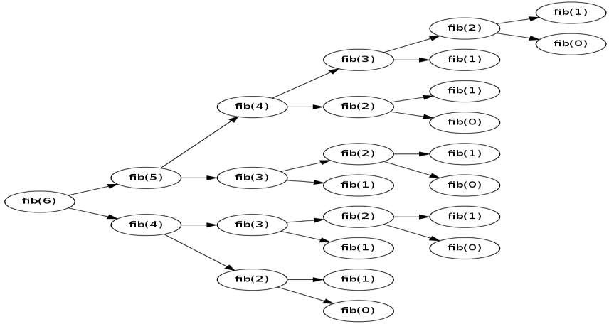
  - We can clearly see the overlapping subproblem pattern here,
as fib(2) has been evaluated twice and fib(1) has been evaluated three
times.

Optimal Substructure Property#

Any problem has optimal substructure property if its overall optimal solution can be constructed from the optimal solutions of its subproblems.
- For Fibonacci numbers, as we know,
Fib(n) = Fib(n-1) + Fib(n-2)
- This clearly shows that a problem of size ‘n’ has been reduced to subproblems of size ‘n-1’ and ‘n-2’.
- Therefore, Fibonacci numbers have optimal substructure property.

Transshipment Model
  - Succinctly, the transshipment model is an extension of the classical transportation model where an item available at point i is shipped to demand point j through one or more intermediate points.
  - Transshipment model is a multi-phase transport problem in which the flow of material – raw materials and services is interrupted in at least one point between the origin and the destination.
  - The whole stock passes through intermediate points of reloading before the goods reach their final destination.
  - The transshipment model helps the management of a company in deciding the optimal number and location of its warehouses.

Example of Transshipment Model
    - A company has nine large stores located in several states.
    - The sales department is interested in reducing the price of a certain product in order to dispose all the stock now in hand.
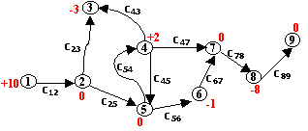
    - But, before that the management wants to reposition its stock among the nine stores according to its sales expectations at each location.

MOD 6 - Optimization in Networks 31

    - The above figure shows the numbered nodes (9 stores).
    - A positive value next to a store represents the amount of inventory to be redistributed to the rest of the system.
    - A negative value represents the shortage of stock.
    - Thus, stores 1 and 4 have excess stock of 10 & 2 items respectively.
    - Stores 3, 6 & 8 need 3, 1, and 8 more items respectively.
    - The inventory positions of stores 2, 5 & 7 are to remain unchanged.

    - An item may be shipped through stores 2, 4, 5, 6, 7 & 8.
    - These locations are known as transshipment points.
    - Each remaining store is a source if it has excess stock, and a sink if it needs stock.
    - In the above figure, store 1 is a source and store 3 is a sink.
    - The value cij is the cost of transporting items.
    - To transport an item from store 1 to store 3, the total shipping cost is c12 + c23

Service tours and vehicle scheduling
    - Service tours and vehicle scheduling focus on developing and applying optimization models and algorithms to assign vehicles to a set of required trips while minimizing costs (e.g., fleet size, operational costs, passenger waiting time) and adhering to various constraints.

Modeling Approaches and Algorithms
    - Researchers use various methods, often falling under the umbrella of Operations Research (OR).

- Network Flow Models: A common approach is formulating the problem as a minimum-cost network flow or circulation problem, where nodes represent locations at specific times and edges represent potential vehicle movements (service or empty trips)

Heuristics and Metaheuristics
    - Due to the complexity (NP-hard nature) of many vehicle scheduling problems, especially for large-scale instances, heuristics are widely used to find high-quality, near-optimal solutions within practical timeframes.
    - Examples include:
- Greedy Algorithms
- Genetic Algorithms
- Tabu Search
- Particle Swarm Optimization
- Large Neighborhood Search

Integrated Approaches
    - Some research focuses on integrating the vehicle scheduling problem (VSP) with other planning stages, such as crew scheduling (CSP) or timetable synchronization, to achieve further cost reductions and better overall system performance.

Data-Driven and AI Methods
    - Current trends leverage real-time data, AI, and machine learning to improve the accuracy and adaptability of scheduling algorithms, predicting traffic patterns and optimizing routes on the fly.

Savings and other heuristic methods
    - Savings methods refer specifically to a class of heuristic algorithms primarily used in operations research for solving problems like the Vehicle Routing Problem (VRP)
    - Heuristics in research are practical problem-solving approaches that use mental shortcuts or experience-based techniques to find a satisfactory, though not necessarily optimal, solution quickly, especially when exact mathematical solutions are too complex or time-consuming.

Savings Methods in Research
    - The most prominent example is the Clarke and Wright Savings (CWS) algorithm, a constructive heuristic used in logistics and supply chain management to minimize transportation costs and distance.

Core Concept
    - The algorithm starts with a solution where each location is served by its own vehicle route.
    - It then calculates the "savings" achieved by merging two different routes into a single route.

- Mechanism
    - The potential savings (𝑆𝑖𝑗) of merging two nodes 𝑖 and 𝑗 into the same route is calculated based on the distance from the depot (𝑑0𝑗) and the distance between the nodes (𝑑𝑖𝑗):

𝑆𝑖𝑗=𝑑0𝑖+𝑑0𝑗−𝑑𝑖𝑗.
    - The algorithm iteratively merges the pair of routes with the greatest savings, provided that vehicle capacity and time constraints are not violated, until no more feasible merges are possible.

Application
    - This method is widely used in real-world scenarios to plan efficient delivery routes for large fleets, often providing good solutions in a very short computational time, which is crucial for daily operations.

In Psychology and Decision-Making (Behavioral Economics)
    - These describe mental shortcuts humans use to make quick judgments in everyday life.
- Availability Heuristic: Judging the likelihood of an event based on how easily examples come to mind.
- Representativeness Heuristic: Evaluating the probability of an event by comparing it to an existing mental prototype or stereotype.
- Affect Heuristic: Relying on immediate emotional responses (positive or negative feelings) to make a quick decision.
- Anchoring and Adjustment Heuristic: Starting with an initial value (anchor) and adjusting it, often insufficiently, to reach a final
estimate.
MOD 6 - Optimization in Networks 44

In Qualitative Research
    - Heuristic inquiry is a specific qualitative research methodology where the researcher's personal experience and self-reflection are central to the discovery and understanding of a phenomenon.
    - The process involves several phases:
- Initial Engagement
- Immersion
- Incubation
- Illumination
- Explication

Urban transport planning
    - Focuses on integrating land use and transport systems to improve accessibility and sustainability.
    - Key research areas include using systems-based models like Transit-Oriented Development (TOD), addressing challenges such as traffic congestion and urban sprawl, and promoting holistic approaches that incorporate public health, environmental goals, and equitable access.
    - Researchers also examine stakeholder engagement, policy implementation, and the development of new tools for decision- making to manage complex urban transport systems.

Key areas of research
- Land use and transport integration: Research examines the critical link between how a city is built and how people move within it, showing that land use patterns heavily influence travel behavior and vice versa.
- Multi-modal systems and connectivity: Studies focus on connecting
different transport modes, such as linking high-capacity systems like metros with feeder services and active mobility options like walking and cycling. A major focus is on improving "last-mile access" to make public transport more convenient.
- Sustainability and climate change: A significant body of research aims to reduce the negative impacts of urban transport, including traffic congestion, fossil fuel consumption, and greenhouse gas emissions. This involves developing more energy-efficient systems and mitigating the

- Safety and accessibility: Research investigates how to design urban spaces that are safer for all users, particularly vulnerable road users like pedestrians and cyclists. This includes research into creating dedicated walkways, safe crossings, and cycling lanes.
- Planning and policy effectiveness: Studies analyze existing
policies and their implementation to understand what works and what doesn’t.
- They look at institutional challenges, funding mechanisms, and the effectiveness of different planning approaches like the Sustainable Urban Mobility Planning (SUMP) framework.

Traffic flows
  - Investigates the relationship between traffic variables like flow, density, and speed to understand, model, and predict congestion and optimize transportation systems.
  - Models can be microscopic (individual vehicles), mesoscopic (city-wide networks), or macroscopic (large regions), and use tools like simulation, data analysis, and AI to study everything from driver behavior to predicting future conditions.

Applications of traffic flow research
  - Urban planning: Inform the design and capacity of new roads and intersections.
  - Traffic management: Develop strategies and implement
technology to manage congestion and improve flow, such as synchronizing traffic lights.
  - System optimization: Improve the efficiency of overall
transportation networks.
  - Environmental impact: Estimate vehicle emissions by characterizing the pollution generated under different traffic conditions.

Inventory models
- Inventory models are mathematical frameworks used to determine the optimal quantity and timing of stock to minimize costs while meeting customer demand.
- Key areas of research include balancing the trade-offs between holding, ordering, and shortage costs, as well as developing both deterministic models for predictable demand and stochastic models for uncertain demand.
- Advanced models incorporate real-world constraints like lead times, production capacity, and sustainability concerns, and have been a central focus of operations research for decades.

Types of inventory models
    - Deterministic models: Used when demand is known and can be forecast with high precision.
      - Economic Order Quantity (EOQ): A foundational model that
calculates the optimal order quantity to minimize total inventory costs.
    - Stochastic models: Used when demand is unpredictable or random, often incorporating a safety stock to buffer against variability.
      - Q-system (reorder point model): An order quantity is fixed, and
an order is placed when inventory level drops to a specific reorder point (𝑆).
      - Periodic review system: Inventory is checked at fixed intervals, and an order is placed to bring the inventory up to a predetermined

Gantt Chart
- A Gantt chart is a type of bar chart that illustrates a project schedule, named after its inventor, Henry Gantt, who designed such a chart around the years 1910–1915.
- Modern Gantt charts also show the dependency relationships between activities and the current schedule status.

- A Gantt chart is a bar chart that provides a visual view of project tasks scheduled over time.
- A Gantt chart is used for project planning: it’s a useful way of showing

what work is scheduled to be done on specific days.
- It helps project managers and team members:
- view the start dates,
- end dates and
- milestones of a project schedule in one simple stacked bar chart.

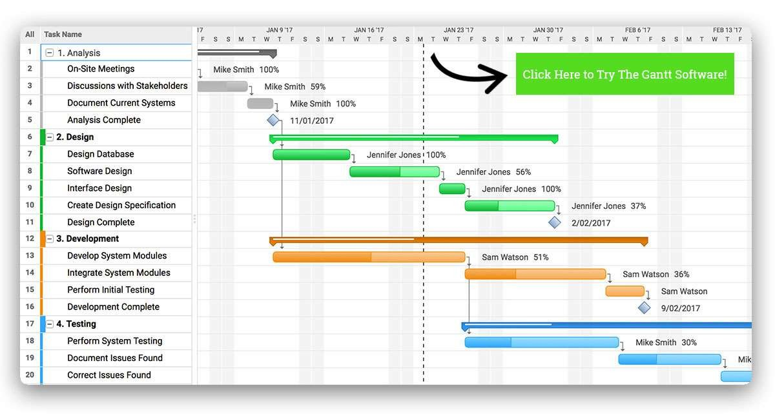
Gantt Chart

Why Gantt Chart?
- Just imagine how difficult it is to juggle numerous balls at once.

You miss a ball and the entire act is gone for a toss.
- Project management is quite similar to juggling where you are constantly ‘juggling’ between multiple tasks, people, projects and what not.

The moment you miss a deadline, the entire planning can go haywire and have serious repercussions.
- This is why it’s helpful to have a visual overview of a project schedule and know when is each activity completing and who is working on it.
- And, this is where Gantt chart software come into the picture.

  - Not just project managers, in fact, people from all walks of life are now using them to plan, organize, and deliver.
  - Before jumping straightaway to its benefits, let’s first understand what they really are:

Why is Gantt chart useful?
  - If you are wondering what is Gantt chart used for and why it is useful for leaders, you need to know that these charts simplify the planning process.
  - Since they are simple to create, use, and keep track of, they prove to be of great help for managers.
  - A Gantt Chart, in its simplest form, is a timeline that illustrates how the project will progress during the project management process.
  - And the timeline view offered by Gantt Charts is proven quite useful for planning and scheduling projects.

  - It (timeline) helps project managers and project teams to;
- assess how long a project should take,
- determine the resources needed,
- understand the dependencies between tasks, and
- plan the order in which each task will be completed if the whole project is to deliver on time.
  - As the project moves forward, a Gantt chart adjusts simultaneously, displaying an up-to-date project schedule to keep everyone (teams, clients, and stakeholders) informed of the progress.
  - In addition to this, Gantt charts replace meetings and enhance other status updates.
  - They make it easy for teams to understand task progress and talk about the problems they may encounter.
  - In all, using a Gantt chart or a Gantt chart tool is useful during project management because it allows you to picture your project against the time frame it needs to be done in.

Simulation
    - A simulation is the imitation of the operation of a real-world process or system over time.
    - Simulations require the use of models; the model represents the key characteristics or behaviors of the selected system or process, whereas the simulation represents the evolution of the model over time.

Computer system users, administrators, and designers usually have a goal of highest performance at lowest cost.
    - Modeling and simulation of system design trade off is good preparation for design and engineering decisions in real world jobs.

A simulation is the execution of a model, represented by a computer program that gives information about the system being investigated.
  - The simulation approach of analyzing a model is opposed to the analytical approach, where the method of analyzing the system is purely theoretical.
  - As this approach is more reliable, the simulation approach gives more

flexibility and convenience.
  - The activities of the model consist of events, which are activated at certain points in time and in this way affect the overall state of the system.
  - The points in time that an event is activated are randomized, so no input from outside the system is required.
  - Events exist autonomously and they are discrete so between the execution of two events nothing happens.

Why Simulation?
    - In the field of simulation, the concept of "principle of computational equivalence" has beneficial implications for the decision-maker.
    - Simulated experimentation accelerates and replaces effectively the "wait and see" anxieties in discovering new insight and explanations of future behavior of the real system.
    - Consider the following scenario: You are the designer of a new switch for asynchronous transfer mode (ATM) networks, a new switching technology that has appeared on the marketplace in recent years.
    - In order to help ensure the success of your product in this is a highly competitive field, it is important that you design the switch to yield the highest possible performance while maintaining a reasonable manufacturing cost.

  - How much memory should be built into the switch?
  - Should the memory be associated with incoming communication links to buffer messages as they arrive, or should it be associated with outgoing links to hold messages competing to use the same link?
  - Moreover, what is the best organization of hardware components within the switch?
  - These are but a few of the questions that you must answer in coming up with a design.
  - With the integration of artificial intelligence, agents and other modeling techniques, simulation has become an effective and appropriate decision support for the managers.
  - By combining the emerging science of complexity with newly popularized simulation technology, the PricewaterhouseCoopers, Emergent Solutions Group builds a software that allows senior management to safely play out "what if" scenarios in artificial worlds.
  - For example, in a consumer retail environment it can be used to find out how the roles of consumers and employees can be simulated to achieve peak performance.

***END***

